Title: | Project development plan  Proposal for an animated movie
Task/Lesson No. | Task 2a
Outcomes | 2, 3 & 4
Class: | Applied Information Technology
Area: | Technology & Enterprise
Teacher: | Mr Faulks
Timeline: | 4 weeks
Phone:
Contact email:
Date Issued: | Thursday, 20 August 2009
Date Due: | Part A
Task Notes: | Group Task

This is a group activity in pairs only

Only one submission per group is required

Task 2: You need to set up a company that specialises in safety training films.

Your brief is to make a short safety animated movie for the school directed at some aspect of safety for teenagers.

Brainstorm ideas:

Good social or environmental behaviour
i.e. Power saving, Water conservation, protecting the environment etc.
An issue of Safety
i.e. Car safety, Crossing the road safely, Driving under the influence etc.
An issue of concern
i.e. Binge Drinking, Drug danger, Hitchhiking, Depression, clubbing, spiked drinks or violence, alcohol abuse, P Platers etc.

Setting up your company
You will need to establish yourself as a company,

- Create your own logo and business identity
- Provide letterheads, memos and business cards.
- Set up a budget for making the movie and present a cost for time and materials
- Set up a database of movies or animated movies for reference purposes.
- Provide a storyboard of your planned movie.

You will need to provide a proposal to the school covering the topic you have chosen and what media is being used to present this.

You should investigate safety in the workplace and provide evidence that your company understands the Occupational Health and Safety standards in business. (On MyClasses or use the Internet)

OSH legislation 1996 regulations.pdf

Project development plan Proposal due: 15th August You need to plan the story of your animation (for Task 3), provide a background to your topic and explain the processes that you will be using to create your animation in Task 3 and why you chose this software.

Project development plan must include reviews and testing that you have conducted to see if your proposal is a viable production entity.

Task 3 : 25th August Create a short animated movie approx 20-30 seconds long which is directed at young teenagers…

Use any suitable software that promotes any of the issues above…

Student Marking Grid Task 2b Business Proposal Creating an Animated movie

Student 1 Name:

Student 2 Name:

Item | Mark | Result
Letterheads & Stationery | 10
Company Profile | 5
Budget | 10
Database | 10
Investigation of OHS | 10
Proposal
Points covered Minor/Major | 5
Purpose of the animation | 5
Supporting notes on technique/cost
Software selection justification | 10
Story board
Draft plan designed | 10
How it is represented | 10
Appropriate research and background
Bibliography | 5
Reviews done | 5
Evaluation | 5
Total | 100

Teacher’s comments:

Proposal: Write up a proposal (sample enclosed) covering

- Introduction to your task, what is required?

- How you intend to complete the task?

- The kind of information and or features you are going to include?

- The research you will need to complete task?

- The intended target audience and how you will make your information relevant?

- Hardware and software you will use to complete the task?

- Time plan (Journal) how you will manage your time?
All tasks require a journal (Download the journal template from MyClasses)
Complete the journal (one per group or one per person for non group tasks

Date | Research or investigation undertaken | Group person initials | Links used  (Copy & Paste links) | Action taken | Notes I.e. used in task – Not considered suitable etc.
 | Add more rows as required

- Any other information that is relevant

SAMPLE PROPOSAL FOLLOWS…

Proposal (your name)

Name of Task/Assignment/Essay

The Proposal
If your essay requires a proposal, do not assume you can whip together something quickly and consider it complete. Chances are, if a professor or teacher is requesting an essay proposal at all (which means more work for them to do), they intend to actually pay attention to it. It may even have a grade value as part of the overall essay. You will likely be held to promises made in the proposal, so don't state that you'll do impossible things under the assumption that the professor or teacher will be impressed.

I/we will present the following:

Major points
Statement of your topic and summary of the entire proposal

Minor points
Purpose and aims of the study

Bibliography
List of references that you intend to use…
- Bogus, Michelle: Widget Watching in the Late 1800s, 1968, Publishers Anonymous Inc., New York

A sample proposal

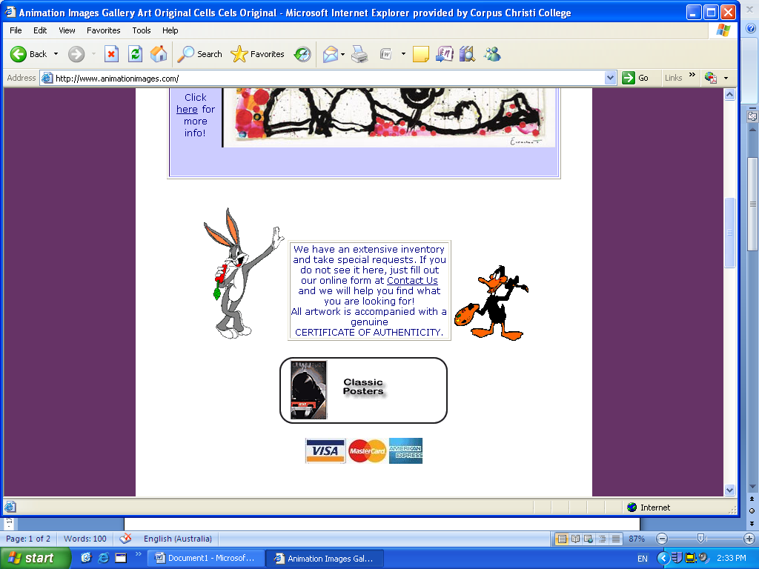
Proposal for A History of Animation


So Doctor what are the symptoms …” they are cartoon people with funny yellow faces”

Peter J Faulks

Applied Information Technology 2b

If you can imagine it, you can achieve it. If you can dream it, you can become it.

Sample Proposal for “A History of Animation”

Background
I will cover various types of animation in a timeline using Power Point as my preferred software package. I will demonstrate various aspects of animation with samples and some background information. History will cover flip page, claymation, stop motion, and digital. In both big screen small screen and other media.

I will show working samples of various animation techniques

Major aspects
I will cover the topic of violence in animation under the heading of Social Implications, having considered why animations are made what their underlying purpose is i.e. Animated cartoons that reflect society like the “Bee Movie” which shows how we are created just for producing goods in a factory type setting each of us allocated to a specific task in life.

I will provide journal evidence and a bibliography that supports my findings.

Peter J Faulks
You should already be well into your research by the time you hand in a proposal. If your proposal is to sound at all informed, you should have already skimmed through some sources to get a feel for the topic. Your research may not be complete, but you should know some of the sources you will use and where your focus lies.
Proposals are usually very specific to the assignment, so be sure to read the assignment carefully. Ensure that you cover all necessary aspects of the assignment in the proposal. Even if you don't fully explain every section - after all, it's not the full essay - do be sure to include the sections you plan to discuss. Also be sure that your list of resources is comprised of books you can actually get and truly plan to read.
Some proposals can be in point form while others are required to be in formal prose. Whichever is the case, do be sure to follow the rules of grammar where necessary, and stick to the other guidelines in these pages. The exception is that most of the time, it is okay to personalize proposals. You shouldn't use "I" and "me" in the full essay, but since the proposal is your personal statement as to your intentions, it is usually okay to do so there.
Here then, is a pretend assignment and a proposal to go along with it (using the fake science of "widgetry"):

Assignment
The essay for Honours Widgetry 101 is to be a 10 to 15 page work concentrating on some aspect of widgetry as learned in the course. Appropriate subjects would be:
- Joe Smith and the widgetiscope
- Jane Doe, the first woman recognized in widgetry
- Prehistoric widgets
- British widgetry versus Chinese widgetry, a comparison of two diverse methods
If you wish to cover an alternate topic, it is recommended that you consult the instructor first.
The essay may cover the personal aspects of widgetry, but it is essential to include some scientific content. This may be in the form of explanations of studies done, archeological indications of prehistoric widgets and their uses, or other scientific data. It is insufficient to merely write about widgets in society. The scientific data must be discussed by the student and not merely quoted from references.
Required elements include:
- a bibliography of no less than seven distinct sources (meaning seven different authors), no more than 30% of which are web-based
- a proposal of no less than 250 words declaring your topic, sources, and the nature of the scientific content you wish to include due by Sept. 30 (not in point form)
- a first draft that is a complete essay but will be graded gently with suggestions for improvement, due by November 1
- a final draft due by December 15.
All instances of suspected plagiarism will be turned over to the university administration without discussion. If the administration decides plagiarism has occurred, the student will automatically receive an F in this course and may be expelled from the university. This edict applies to all proposals and drafts. No warning will be given; all students are expected to know how to avoid plagiarism by this stage in their education.

Proposal
Joe Smith and The Widgetiscope
A proposal by Kimberly Chapman
According to Jean Doorknocker, "In the vast field of widget watching, no one person has made more of a dramatic contribution than Joe Smith" (Doorknocker 37). Widget watching began in ancient Sumeria, but reached its scientific peak in the late 1800s when Smith invented the widgetiscope (Diddledum 203-204). My essay will examine Smith's involvement in and contributions to the field as well as his personal life. Since Smith's adult life revolved almost entirely around his studies (Doorknocker 39), I believe his personal story is essential to understanding how he came to invent the widgetiscope.
Born in Scotland in 1856, Smith was orphaned early due to a plague. He was adopted while still a toddler and taken to the U.S. by his new American parents (Superwriter 4-7). He attended prestigious schools, eventually meeting a teacher named Brian Googlebrains who introduced young Smith to widgetry (Bogus 93).
A socially awkward boy, Smith took to widgetry quickly because it gave him an excuse to avoid bullies in the school playground (Doorknocker 37). His social problems never really abated; recent information suggests that he may have committed suicide when, because of his alcoholism, he was threatened exclusion from his dearly-held association of New York Widget Watchers(Doorknocker 38-39).
Smith's devotion to widgetry is evident in his many publications, which will be individually discussed in my essay. It was his invention of the widgetiscope, however, that truly marked his place in the field. The essay will thoroughly cover the invention process (including excerpts from Smith's diary as found in Bogus' book), how it works, a diagram of the parts of the widgetiscope, commentary from Smith's colleagues on the device as found in several sources, and a discussion of how the invention changed the field from a pastime into a science. For this last part, I will include citations from several sources as well as my own analysis of the state of widgetry before and after the invention.

Bibliography
- Bogus, Michelle: Widget Watching in the Late 1800s, 1968, Publishers Anonymous Inc., New York
- Diddledum, Frank: Widget Watchers in History, 1974, Frinkle Publishers, Los Angeles
- Doorknocker, Jean: Joe Smith, Portrait of a Widget Watcher, Widgets Monthly, August 1996, Volume 15, Number 8
- Driesel, Fran: Widget Watching, http://www.website.com/joesmith/widgetwatching.html
- Schultz, Patty: The Wonderful World of Widgets, 1982, Publishers Anonymous Inc., New York
- Smith, Joe: Widgets and the Solstice: An Experiment in Balance 1885, Reprinted in Widgets Monthly, April 1987, Volume 6 Number 4
- Smith, Joe: The Mysterious Top Widget, 1887, The Journal of Widgetry
- Smith, Joe: A Treatise on Fnordlization of Widgets, 1889, The Journal of Widgetry
- Superwriter, Sally: Joe Smith: His Life and Times, 1958, Schlmup Press New York

Storyboard

OBJECTIVES:
At the end of this lesson students will be able to:
- Students need to organise how they will present the information on PowerPoint slides, therefore determine where the title goes, the type of font size and colour and appropriate images to include.

- At the end of the lesson students should have completed the Sketch Sheet provided.

PREPARATION:
Connect overhead projector to the main computer to demonstrate the following activities to the whole class.
Check students have enough storage space on the computer to save their work.

PROCEDURES:
Show students how to search by explaining how the Boolean Operators work.
AND, OR and NOT.

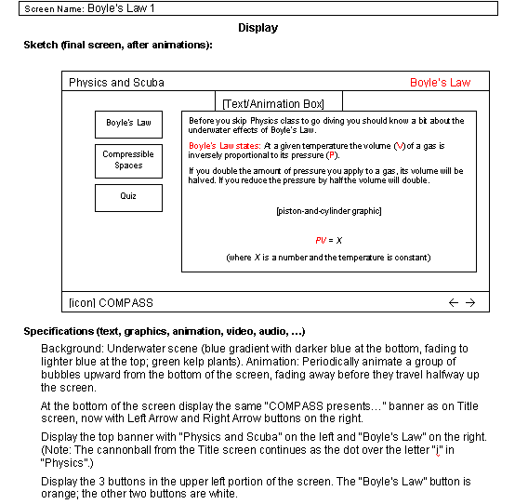

to plan your work
Use one of the storyboard templates below or create your own
Storyboard Sheet

Story Name:__________________________
Draw or sketch your animation, or write what is going to happen
1____________________________  Description of action | 2 __________________________  Description of action
3 ____________________________  Description of action | 4 __________________________  Description of action
5 ____________________________  Description of action | 6 __________________________  Description of action

7 ____________________________  Description of action | 8__________________________  Description of action
9 ____________________________  Description of action | 10 __________________________  Description of action
11 ____________________________  Description of action | 12___________________________  Description of action
13____________________________  Description of action | 14 ___________________________  Description of action
Make more cells as required

Storyboard 2 follows

Storyboard

Frame 1 | Frame 2 | Frame 3
Action | Action | Action
Frame 4 | Frame 5 | Frame 6
Action | Action | Action
Frame 7 | Frame 8 | Frame 9
Action | Action | Action

